CEL 51, DCCN, Monsoon 2020

Lab 4: Prototyping a Network

**Objective:**

Prototype a network using Packet Tracer

**Background**

A client has requested that you set up a simple network with two PCs connected to a switch. Verify that the hardware, along with the given configurations, meet the requirements of the client.

**Step 1: Set up the network topology**

1. Add two PCs and a Cisco 2950T switch

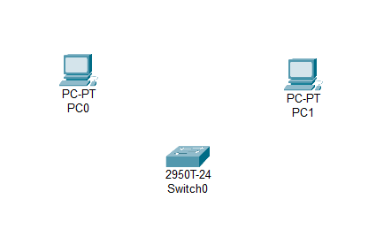

Fig 4.1 – Two PCs and a switch added to the design area

1. Using straight-through cables, connect **PC0** to interface **Fa0/1** on **Switch0** and **PC1** to interface **Fa0/2** on **Switch0**.

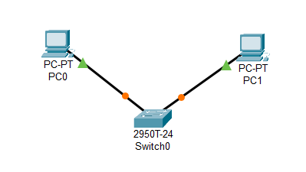

Fig. 4.2 – The Two PCs and Switch are connected to each other using straight through cables and Fast Ethernet Interface

1. Configure PC0 using the **Config** tab in the PC0 configuration window:
   1. IP address: 192.168.10.10
   2. Subnet Mask 255.255.255.0

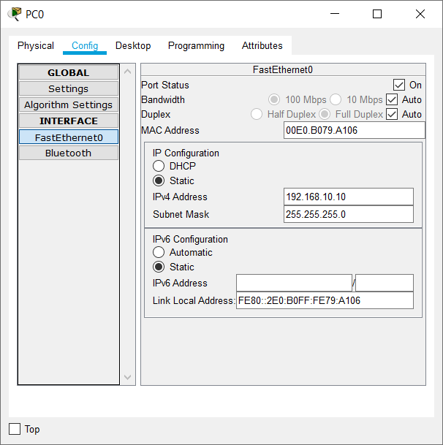

Fig 4.3 – Added the IP Address and Subnet Mask for PC0

1. Configure PC1 using the **Config** tab in the PC1 configuration window
   1. IP address: 192.168.10.11
   2. Subnet Mask 255.255.255.0

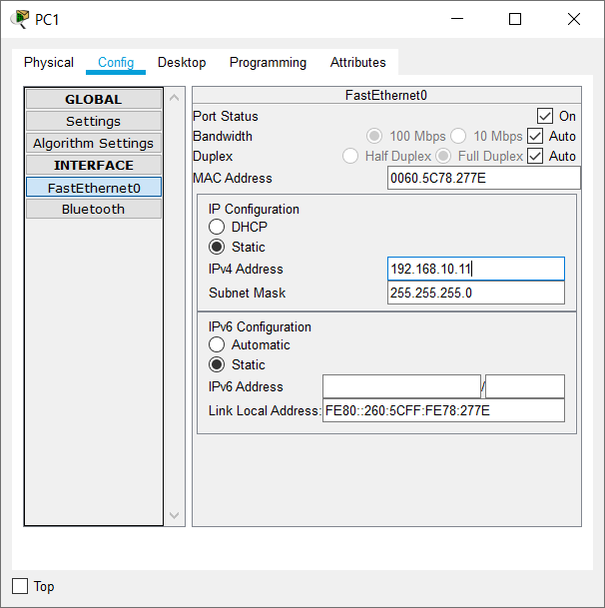

Fig 4.4 – Added the IP Address and Subnet Mask for PC1

**Step 2: Test connectivity from PC0 to PC1**

1. Use the **ping** command to test connectivity.
   1. Click PC0.
   2. Choose the **Desktop** tab.
   3. Choose **Command Prompt**.
   4. Type: **ping 192.168.10.11** and press *enter*.
2. A successful **ping** indicates the network was configured correctly and the prototype validates the hardware and software configurations. A successful ping should resemble the below output:

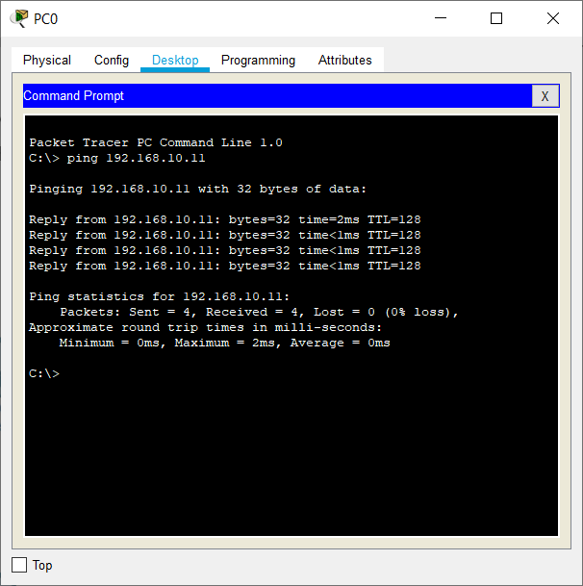

Fig 4.5 – Pinging 192.168.10.11 from PC0 using command prompt

1. Close the configuration window.
2. Click the **Check Results** button at the bottom of the instruction window to check your work.

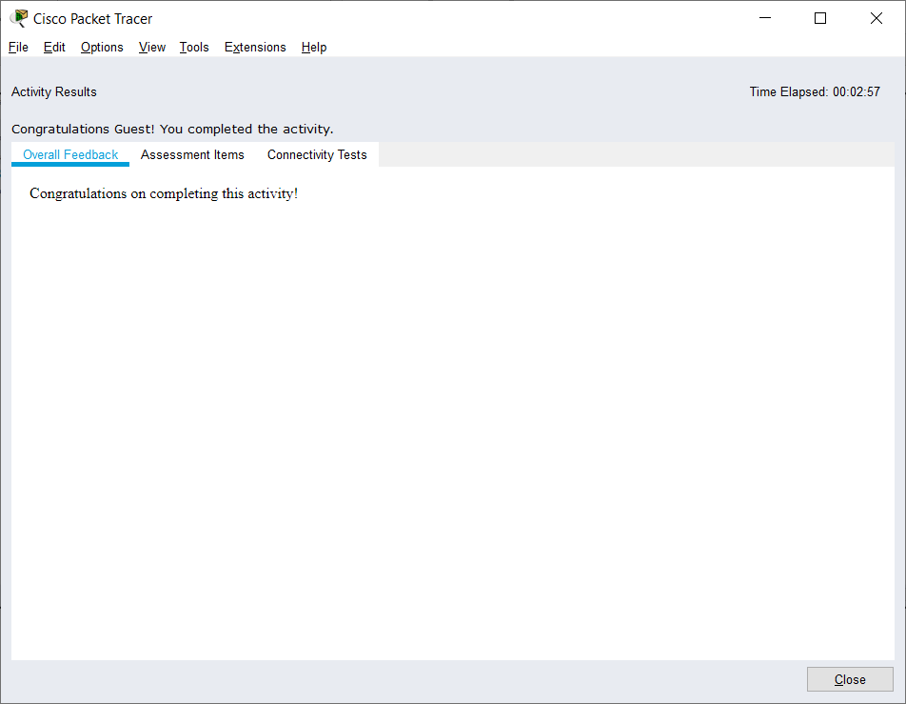

Fig 4.6 – Check results screen

CEL51, DCCN, Monsoon 2020

Lab 4.1: Basic configuration - hostname, motd banner, passwd etc

**Objective:**

This lab will test your ability to configure basic settings such as hostname, motd banner, encrypted passwords, and terminal options on a Packet Tracer 6.2 simulated Cisco Catalyst switch.

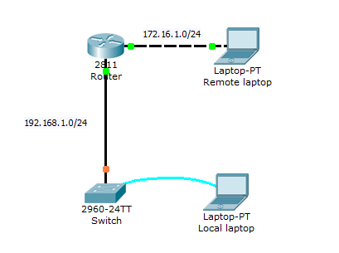

1. Use the local laptop connect to the switch console.

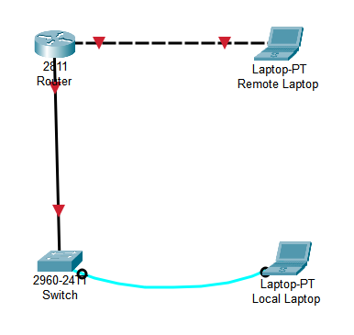

Fig 4.7 – Adding the laptops, switch and router to the design areas and connecting them using respective cables and interfaces

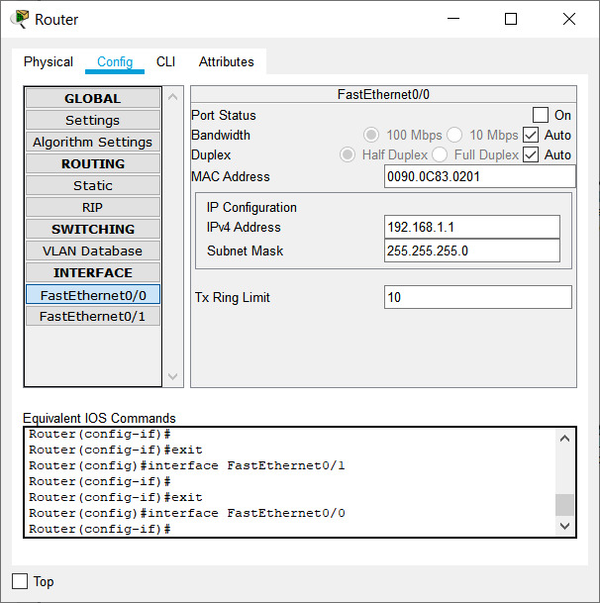

Fig 4.8 – Setting up FastEthernet0/0 for Router (Connected to Switch)

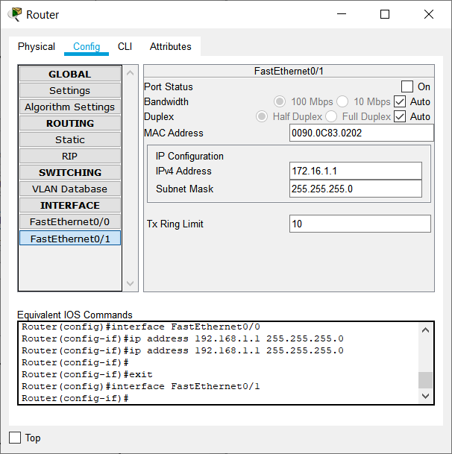

Fig 4.9 – Setting up FastEthernet0/1 for Router (Connected to Remote Laptop)

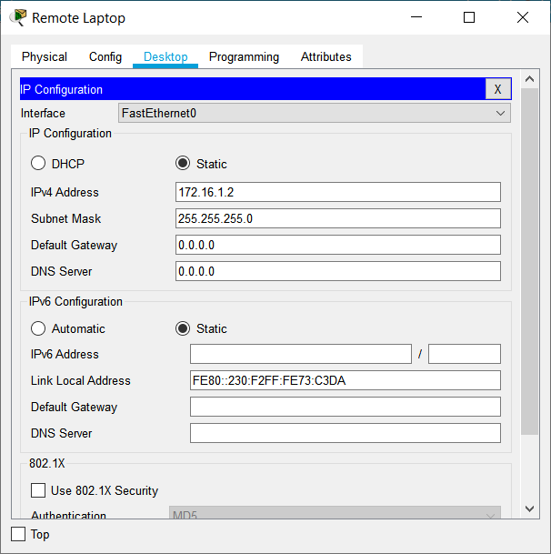

Fig 4.10 – Configuring IP Address, Subnet Mask and Default Gateway for Remote Laptop

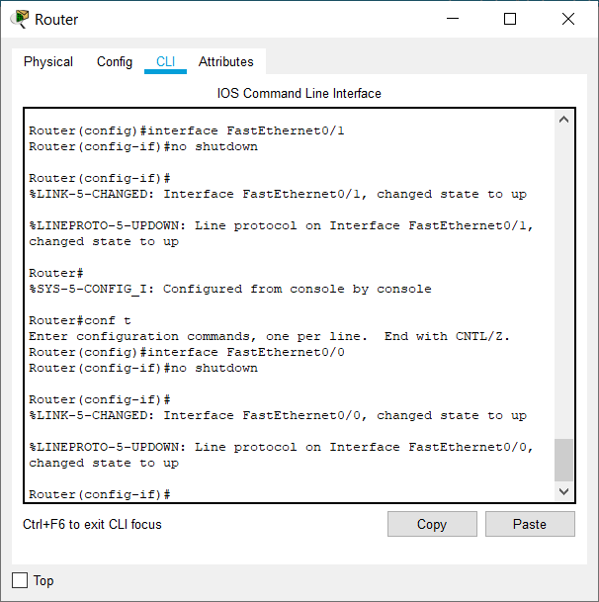

Fig 4.11 – Enabling interfaces FastEthernet0/0 and FastEthernet0/1 using no shutdown command

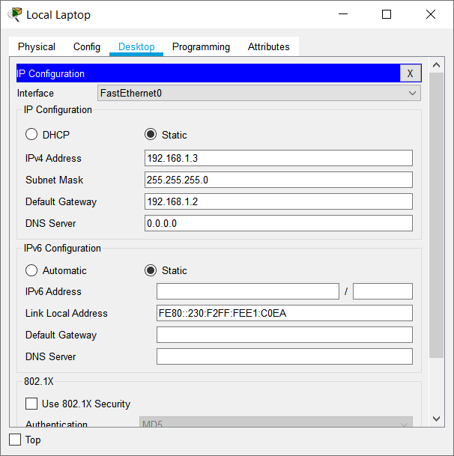

Fig 4.12 - Configuring IP Address, Subnet Mask and Default Gateway for Local Laptop

2. Configure Switch hostname as LOCAL-SWITCH

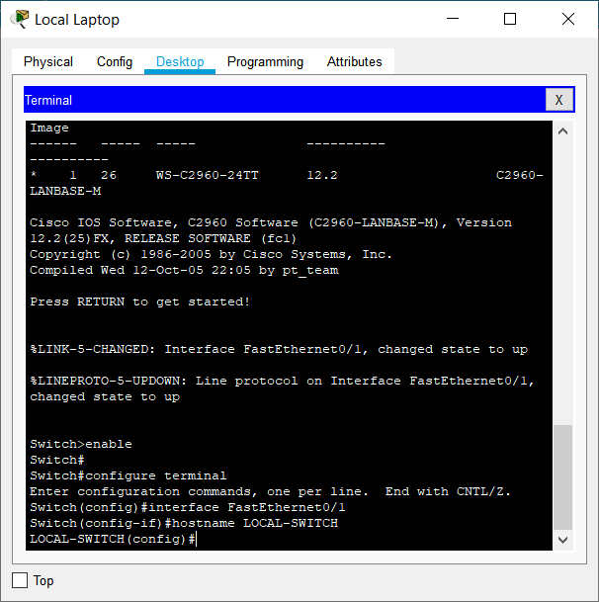

Fig 4.13 – Configuring the switch hostname to LOCAL-SWITCH using console on Local Laptop

3. Configure the message of the day as "Unauthorized access is forbidden"

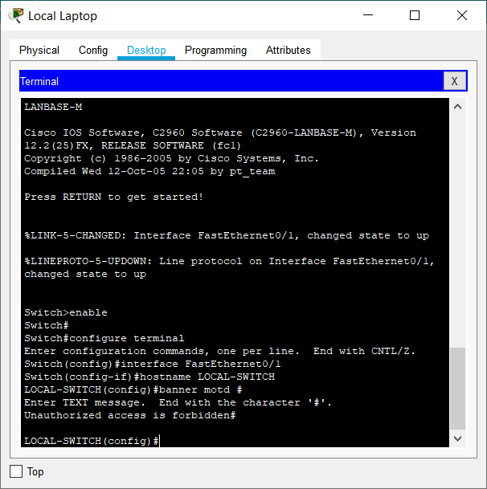

Fig 4.14 – Configuring message of the day of the switch using console on Local Laptop

4. Configure the password for privileged mode access as "cisco". The password must be md5 encrypted

5. Configure password encryption on the switch using the global configuration command

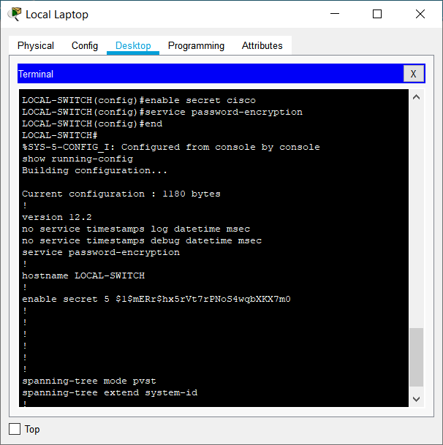

Fig. 4.15 – Configuring the password for privilege mode access and configuring password encryption on the switch

6. Configure CONSOLE access with the following settings :  
- Login enabled  
- Password : whatever you like  
- History size : 15 commands  
- Timeout : 6'45''  
- Synchronous logging

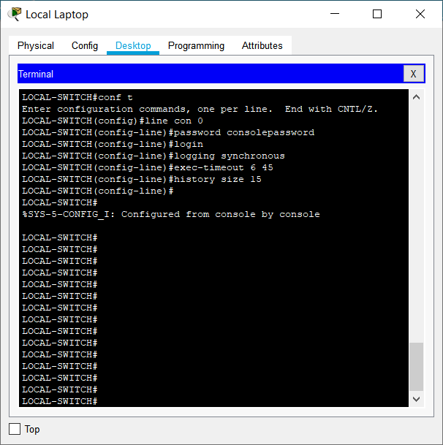

Fig 4.16 – Configuring CONSOLE access on the switch

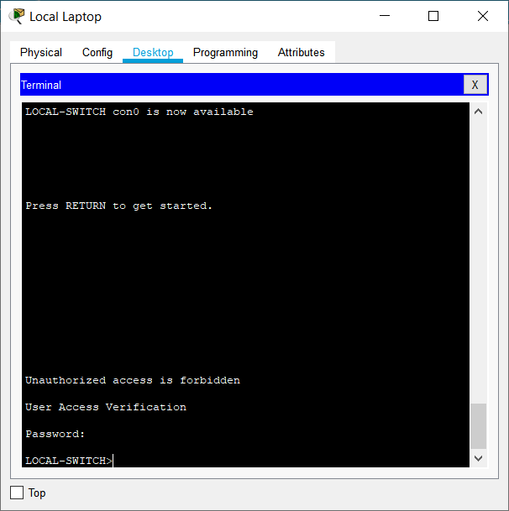

Fig 4.17 – Console access is blocked without password and the message of the day is seen

7. Configure TELNET access with the following settings :  
- Login enabled  
- Password : whatever you like  
- History size : 15 commands  
- Timeout : 8'20''  
- Synchronous logging

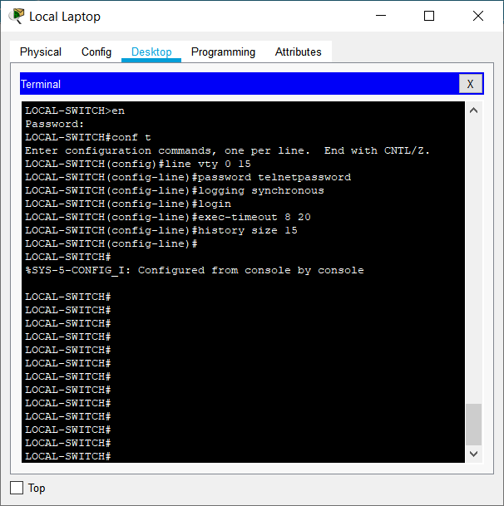

Fig 4.18 – Configuring TELNET access on the switch

8. Configure the IP address of the switch as 192.168.1.2/24 and it's default gateway IP (192.168.1.1).

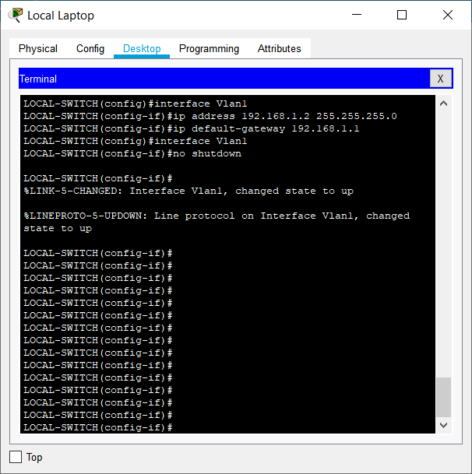

Fig 4.18 – Configuring IP Address and Default Gateway of switch

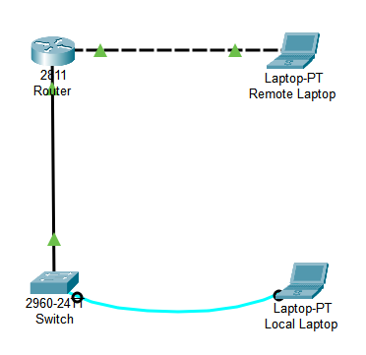

Fig 4.19 – Fully configured network

8. Test telnet connectivity from the Remote Laptop using the telnet client.

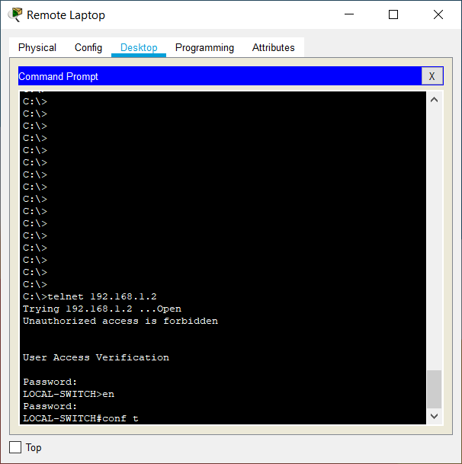

Fig 4.20 – Testing telnet on switch using it’s IP Address. Telnet gives us access to the terminal of the switch. It is password protected and privileged execution is also password protected.

**Extra**

Since we have connected only the console cable from switch to the local laptop, the local laptop only acts as a terminal for the switch. To connect the laptop to the network, I connected a copper straight-through cable to the FastEthernet interface. Since I had already configured the local laptop, I could finally ping from the Remote to Local Laptop (This has to be done first since the local laptop cannot resolve any IP addresses) and vice versa.

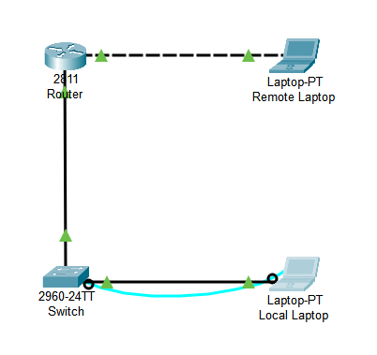

Fig 4.21 – Connected Switch and Local Laptop using Copper Straight-Through cable and FastEthernet interface

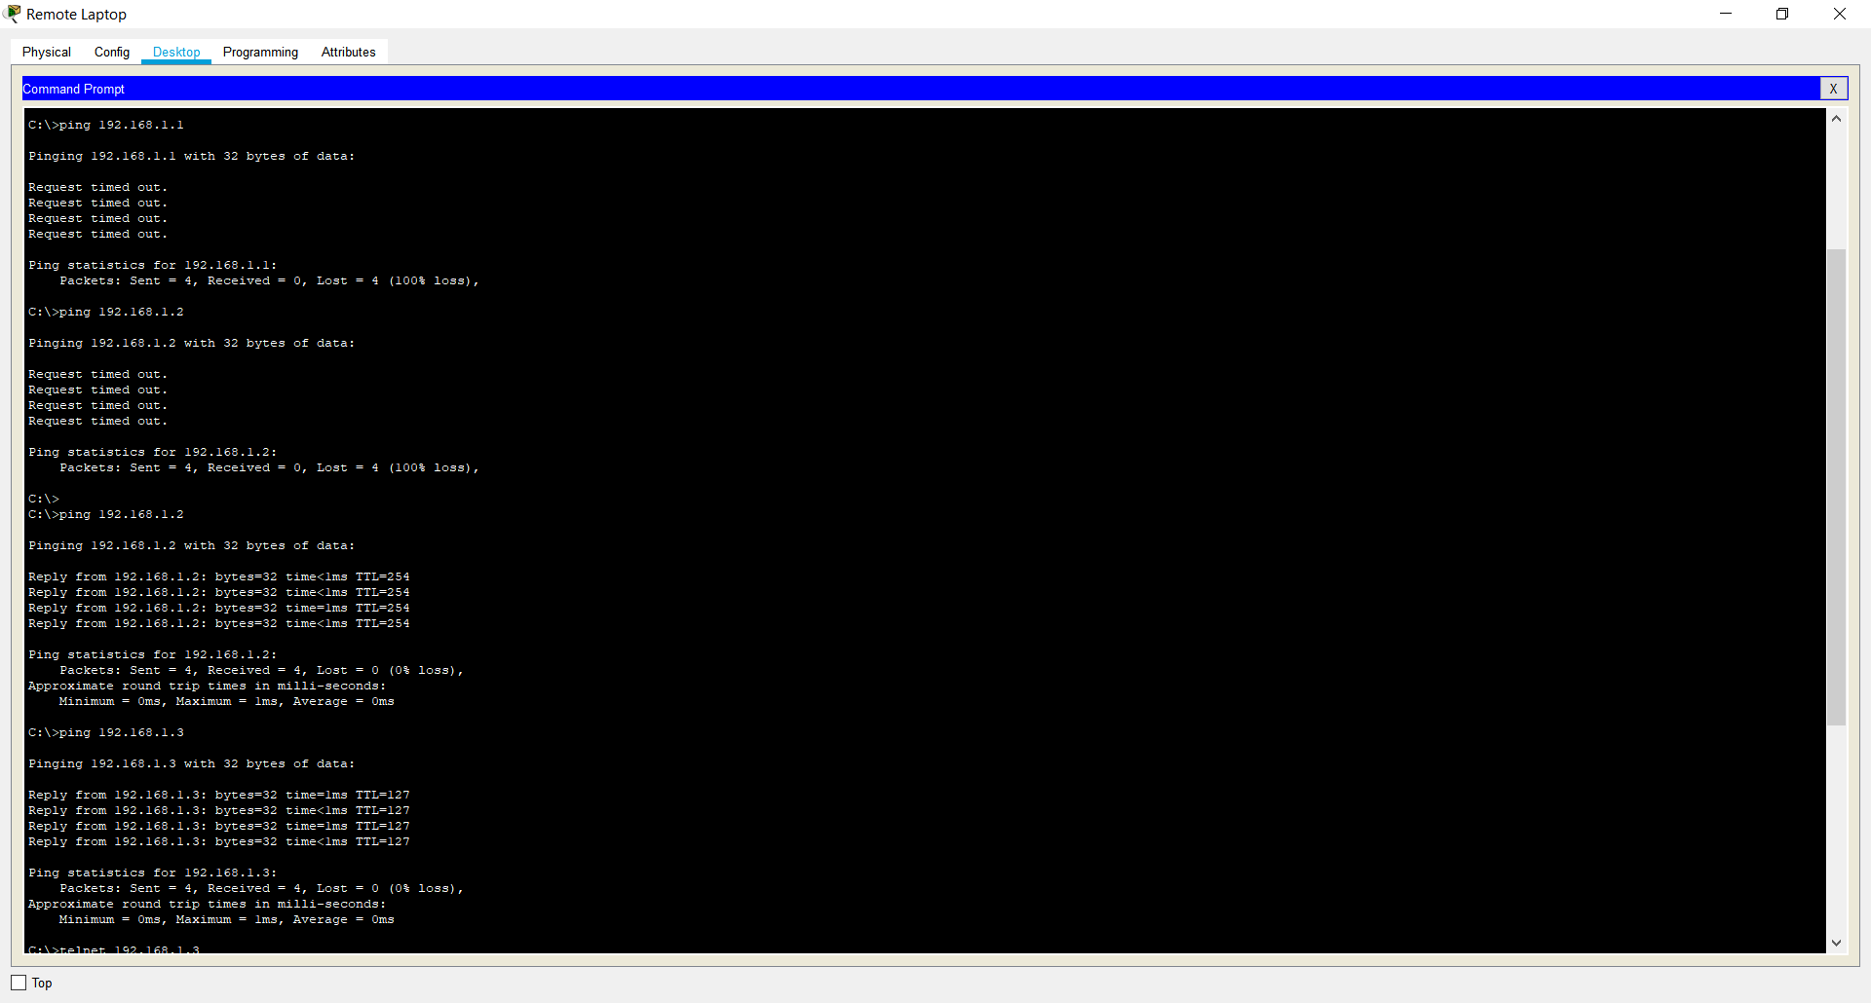

Fig 4.22 – Pinging Switch, Router and Remote Laptop from Local Laptop. Since the ping is successful in the end, it indicates that the network is connected.

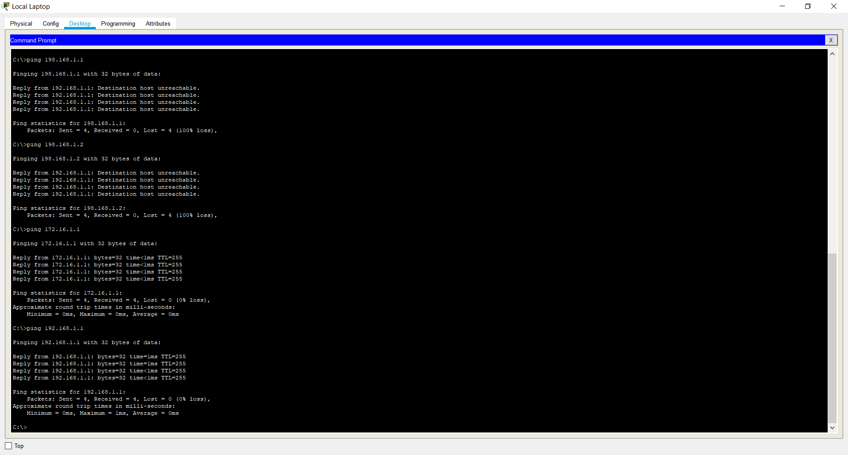

Fig 4.22 – Pinging Switch, Router and Remote Laptop from Local Laptop. Since the ping is successful in the end, it indicates that the network is connected.